

Semester One Examination, 2016

Question/Answer Booklet

MATHEMATICS

SOLUTIONS
METHODS
UNIT 1

Section Two:

Calculator-assumed

Student Number: In figures

In words

Your name

Time allowed for this section
Reading time before commencing work: ten minutes
Working time for section: one hundred minutes

Materials required/recommended for this section
To be provided by the supervisor
This Question/Answer Booklet
Formula Sheet (retained from Section One)

To be provided by the candidate
Standard items: pens (blue/black preferred), pencils (including coloured), sharpener, correction fluid/tape, eraser, ruler, highlighters

Special items: drawing instruments, templates, notes on two unfolded sheets of A4 paper, and up to three calculators approved for use in the WACE examinations

Important note to candidates
No other items may be taken into the examination room. It is your responsibility to ensure that you do not have any unauthorised notes or other items of a non-personal nature in the examination room. If you have any unauthorised material with you, hand it to the supervisor before reading any further.

Structure of this paper

Section | Number of questions available | Number of questions to be answered | Working  time (minutes) | Marks available | Percentage of exam
Section One:  Calculator-free | 7 | 7 | 50 | 51 | 35
Section Two:  Calculator-assumed | 13 | 13 | 100 | 98 | 65
 |  |  | Total | 149 | 100

Instructions to candidates

- The rules for the conduct of examinations are detailed in the school handbook. Sitting this examination implies that you agree to abide by these rules.

- Write your answers in this Question/Answer Booklet.

- You must be careful to confine your response to the specific question asked and to follow any instructions that are specified to a particular question.

- Spare pages are included at the end of this booklet. They can be used for planning your responses and/or as additional space if required to continue an answer.
- Planning: If you use the spare pages for planning, indicate this clearly at the top of the page.
- Continuing an answer: If you need to use the space to continue an answer, indicate in the original answer space where the answer is continued, i.e. give the page number. Fill in the number of the question that you are continuing to answer at the top of the page.

- Show all your working clearly. Your working should be in sufficient detail to allow your answers to be checked readily and for marks to be awarded for reasoning. Incorrect answers given without supporting reasoning cannot be allocated any marks. For any question or part question worth more than two marks, valid working or justification is required to receive full marks. If you repeat any question, ensure that you cancel the answer you do not wish to have marked.

- It is recommended that you do not use pencil, except in diagrams.

- The Formula Sheet is not to be handed in with your Question/Answer Booklet.

Section Two: Calculator-assumed 65% (99 Marks)
This section has thirteen (13) questions. Answer all questions. Write your answers in the spaces provided.

Working time for this section is 100 minutes.

Question 8 (6 marks)
(a) Show how to establish that the exact value of is . (3 marks)
Solution
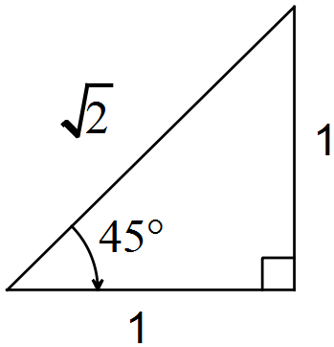
From diagram, it can be seen that .
Using , .
Specific behaviours
sketches isosceles triangle with angle and sides shown
uses triangle to obtain cos45
uses unit circle identity to obtain cos135

(b) The graphs of and are shown below. Determine, to the nearest degree, the size of the angle . (3 marks)

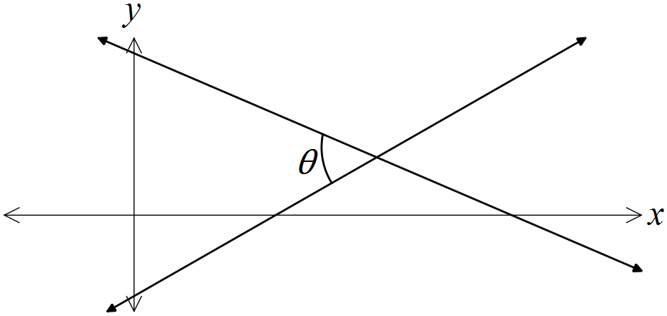
Solution
Specific behaviours
determines both gradients
calculates angle of lines to x-axis
determines required angle

Question 9 (7 marks)
The graphs of the functions, and are shown below, where a, b, c, d, m and n are positive constants.

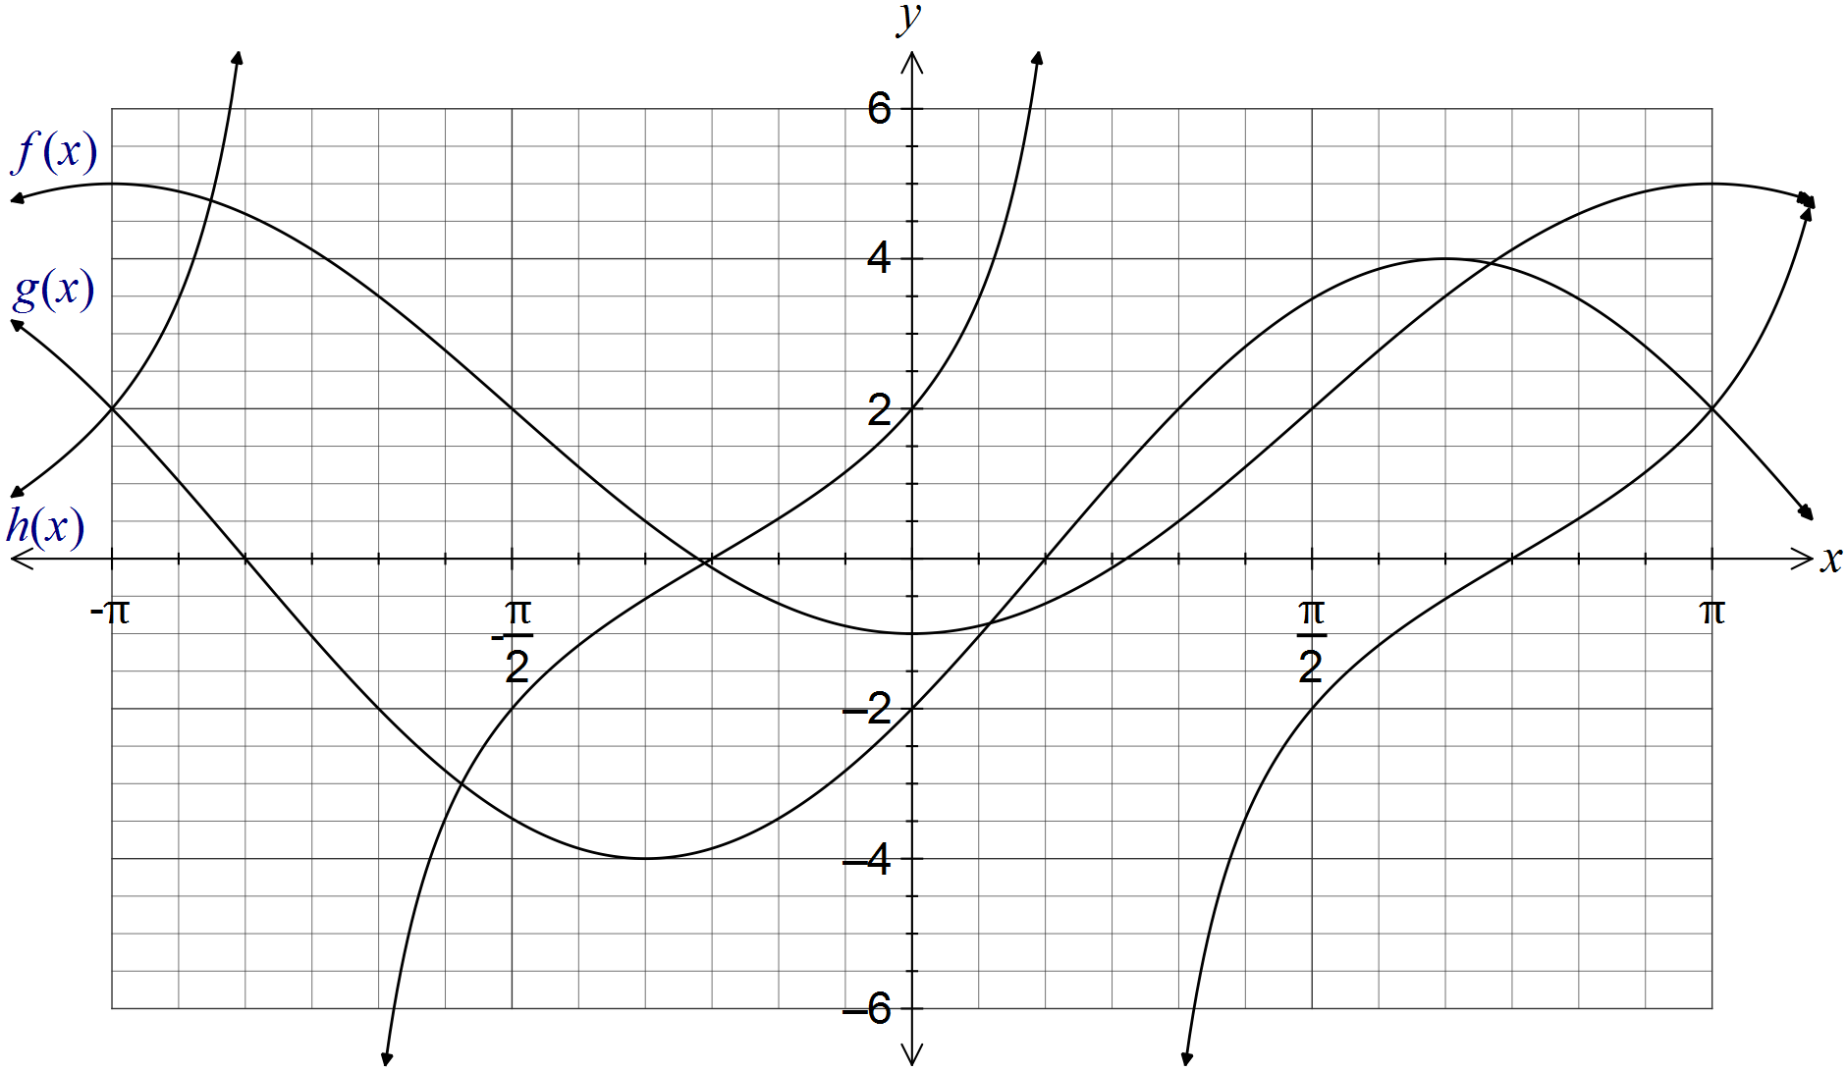

(a) Clearly label each of the functions f, g and h on the graph. (1 mark)

(b) Determine the values of the positive constants a, b, c, d, m and n. (6 marks)
Solution
Cos function has max value of 5, min of -1 and starts at min. .

Sin function has amplitude of 4 and first root at . .
(Strictly, )

Tan function: Root at , and midway between root and asymptote, .
(Strictly, )
Specific behaviours
award one mark per value

Question 10 (7 marks)
(a) The extension, e, of a spring is directly proportional to the mass, m, hung on the end of it. When a mass of 100 g was hung on the spring, its extension was 25 mm.

(i) Write an equation that relates the variables e and m. (2 marks)
Solution
Specific behaviours
writes linear equation using constant of proportionality
determines constant and writes in equation

(ii) Determine m when mm. (1 mark)
Solution
Specific behaviours
determines m

(b) A full water tank can be emptied in 40 minutes using a small pump and in 10 minutes using a large pump. Assuming that the pumps do not affect each other when used together, determine the time required to empty the tank using both pumps. (4 marks)
Solution
Specific behaviours
identifies inverse proportion
determines rate pumps empty in terms of V
substitute rates into equation for T
solves for time
NB choosing an arbitrary volume such as 40 is acceptable and simplifies working

Question 11 (7 marks)
A function is defined by .

(a) State the domain of this function. (1 mark)
Solution
Specific behaviours
states domain restriction

(b) Draw the graph of on the axes below, clearly showing the coordinates of all axis-intercepts and equations of any asymptotes. (4 marks)

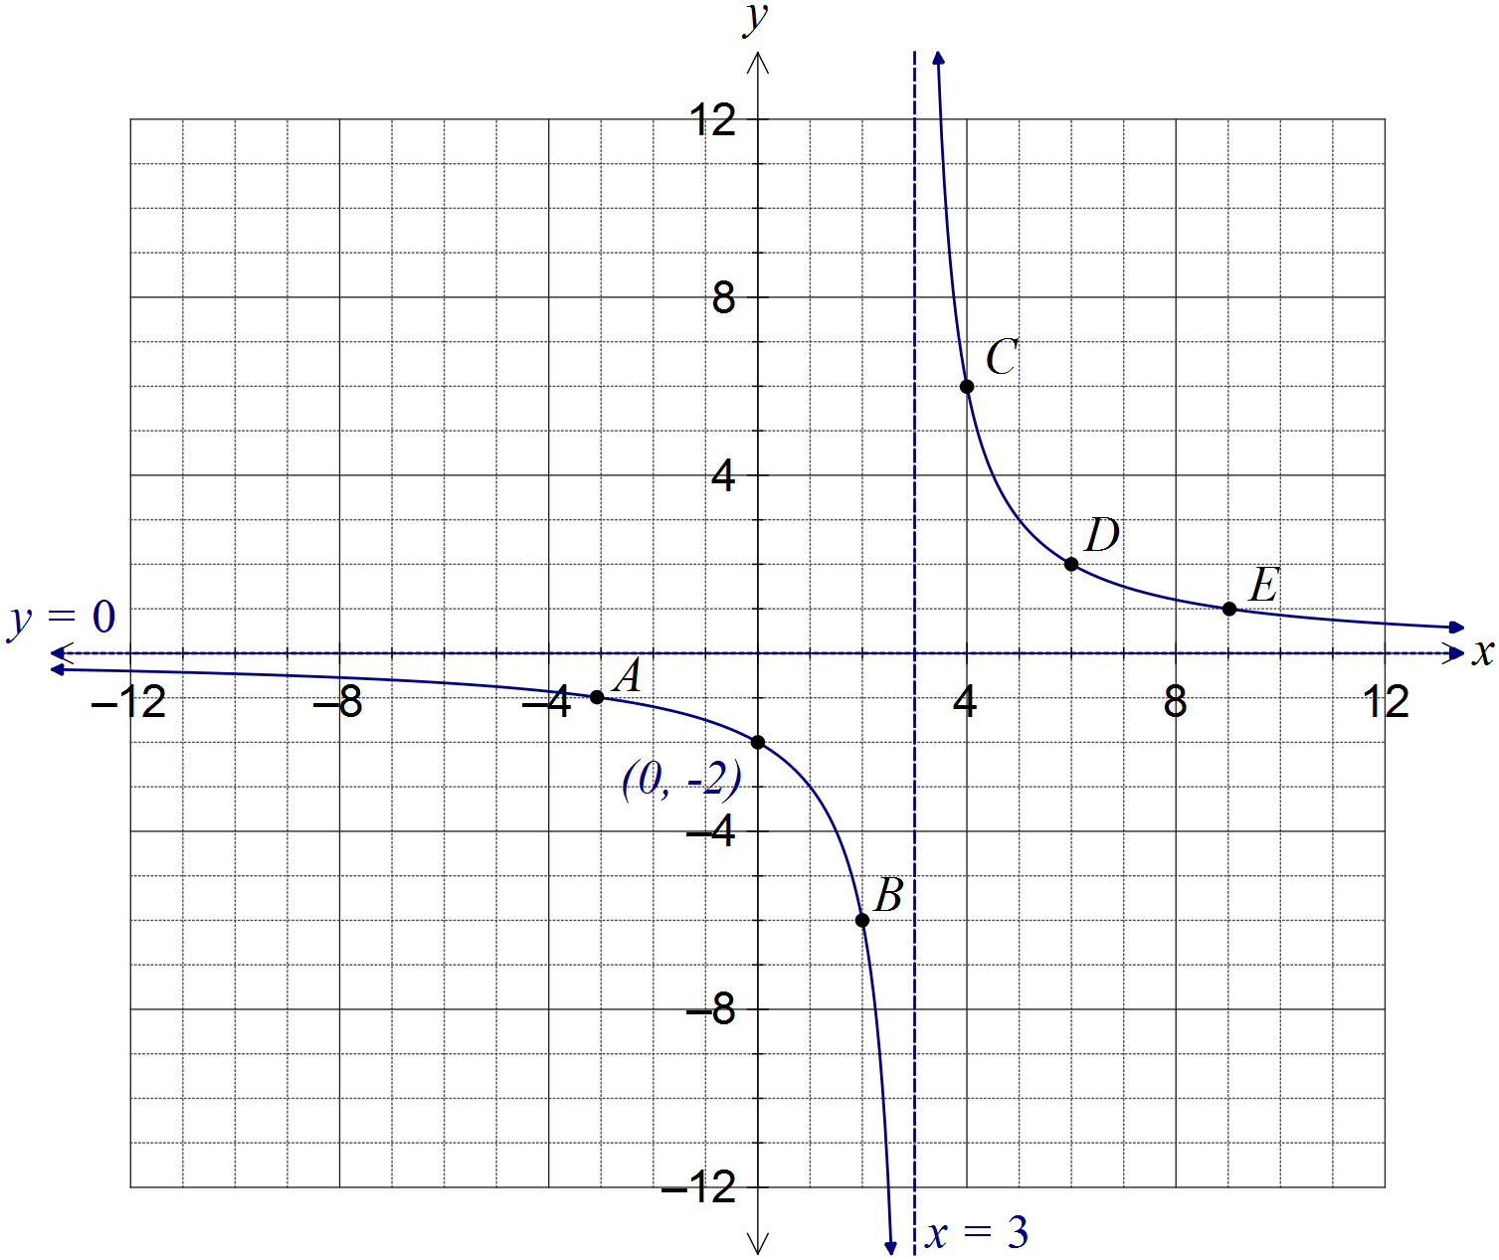
Solution
See graph
Specific behaviours
curves approach vertical asymptote, which is shown with equation
curves approach horizontal asymptote, without hooking upwards
coordinates of y-intercept shown
smooth curve passing through at least 3 of A, B, C, D or E

(c) The graph of is dilated vertically by a scale factor of 4 followed by a translation of three units to the right. Determine the coordinates of the y-intercept of the transformed graph. (2 marks)
Solution
Transforms the point (-3, -1) to (-3, -4) to (0, -4)
or
Specific behaviours
applies dilation
applies translation

Question 12 (8 marks)
(a) A 3.6 m long ladder first rests against a vertical wall BC, making an angle of 70° with the horizontal ground. The ladder is rotated in a vertical plane about E to rest against wall AD, reaching a point 2.6 m above the ground.

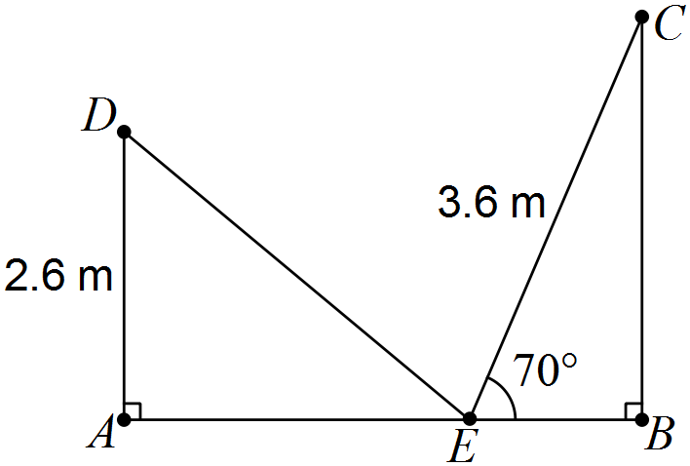

Showing use of trigonometry, determine

(i) the angle through which the ladder was rotated. (2 marks)
Solution
Specific behaviours
calculates angle in triangle
determines rotation angle

(ii) the distance AB. (2 marks)
Solution
Specific behaviours
determines AE
determines EB and adds to get AB

(iii) the distance DC. (2 marks)
Solution
Specific behaviours
uses cosine rule
determines length

(b) A thin metal plate in the shape of an equilateral triangle has an area of 330 cm. Determine the side length of the triangle. (2 marks)
Solution
Let side length be x. Then
Specific behaviours
uses area formula
determines length

Question 13 (9 marks)
(a) A square is inscribed in a circle of radius 16 cm, as shown below. Determine the area enclosed between the square and the circle. (3 marks)

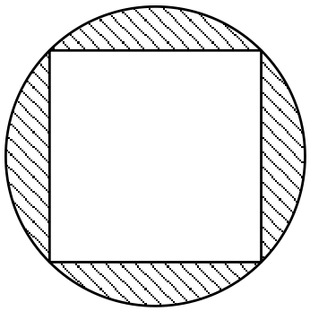
Solution
Specific behaviours
determines segment angle
determines one segment area
determines area of all segments

(b) The perimeter of a sector, with central angle radians in a circle of radius r, is 12 cm.

(i) Express in terms of r. (2 marks)
Solution
Specific behaviours
substitutes into equation for perimeter
rearranges equation for

(ii) Show that the area of the sector is . (2 marks)
Solution
Specific behaviours
substitutes r and into area formula
expands and simplifies

(iii) Determine the area of the sector if . (2 marks)
Solution
Specific behaviours
determines radius
calculates area

Question 14 (7 marks)
A function and a relation have been graphed on the axes below.

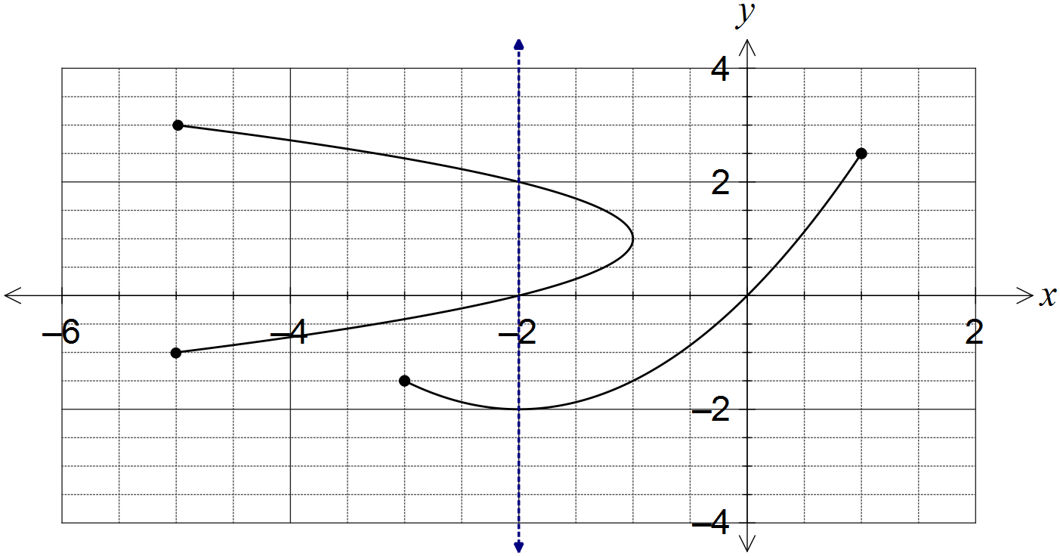

(a) Draw the line on the graph and explain how it can be used to identify the relation. (2 marks)
Solution
See line on graph.
Vertical line cuts the relation more than once, but the function just once.
Specific behaviours
draws vertical line
explains vertical line test

(b) State the domain and range of the function. (2 marks)
Solution
Specific behaviours
states domain
states range

(c) The relation can be expressed in the form . Determine the values of the constants a and b. (3 marks)
Solution
When .
Specific behaviours
selects suitable point from relation
determines a
determines b

Question 15 (9 marks)
A sensor was fitted to the tip of a blade on a wind turbine to measure the height, h metres, of the blade above the ground. The height was observed to vary according to the function , where is the time in seconds since measurements began.

(a) Determine the height of the blade tip above the ground when . (1 mark)
Solution
Specific behaviours
calculates height

(b) Sketch the graph of on the axes below for . (4 marks)

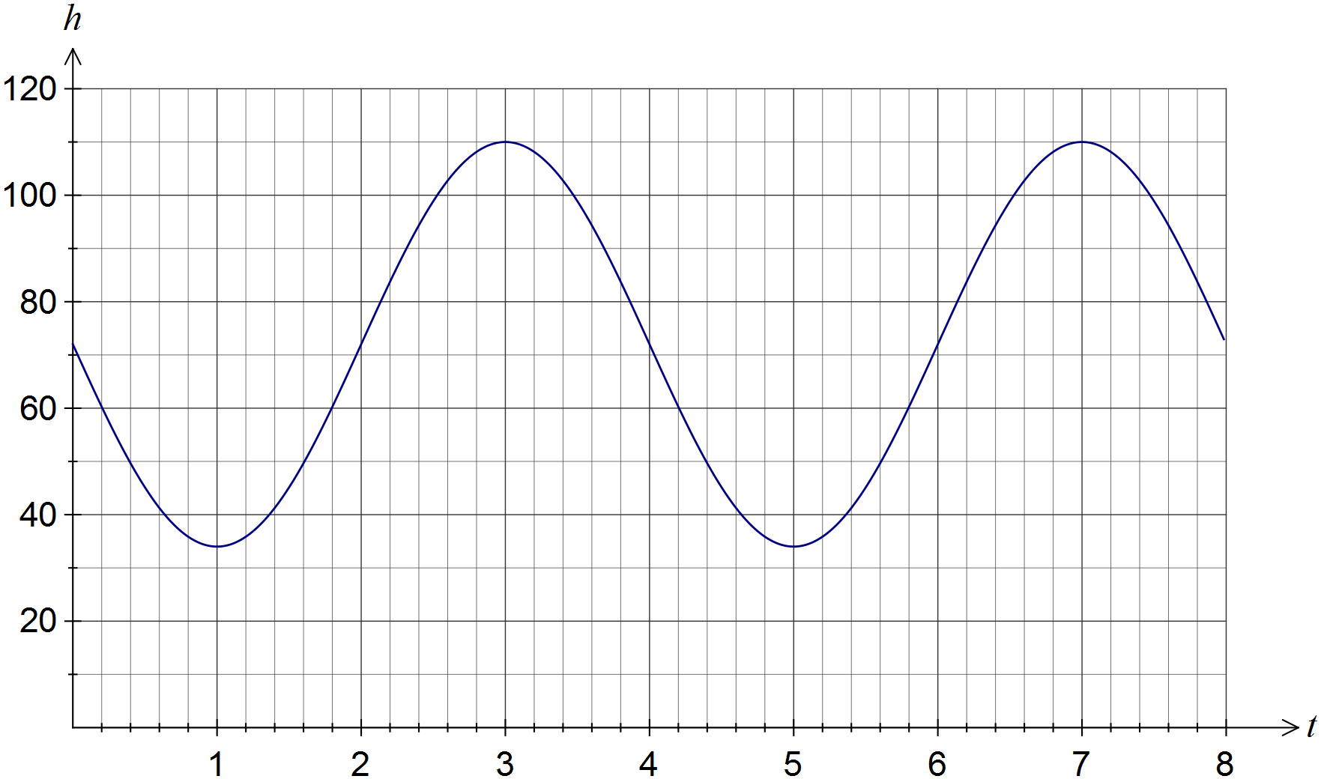
Solution
See graph
Specific behaviours
minimums at (1, 34) and (5, 34)
maximums at (3,110) and (7, 110)
smooth curve through above points, no abrupt 'corners'

(c) How long does the blade take to rotate once? (1 mark)
Solution
4 seconds
Specific behaviours
states time

(d) Assuming the blade continues to rotate in this manner, determine the percentage of time during which the blade tip is at least 90 m above the ground. (3 marks)
Solution
Specific behaviours
solves for height of 90 m
determines interval above 90
determines percentage

Question 16 (7 marks)
The graphs of , and are shown below. Determine the values of the constants a, b, c, d, n, p and q.

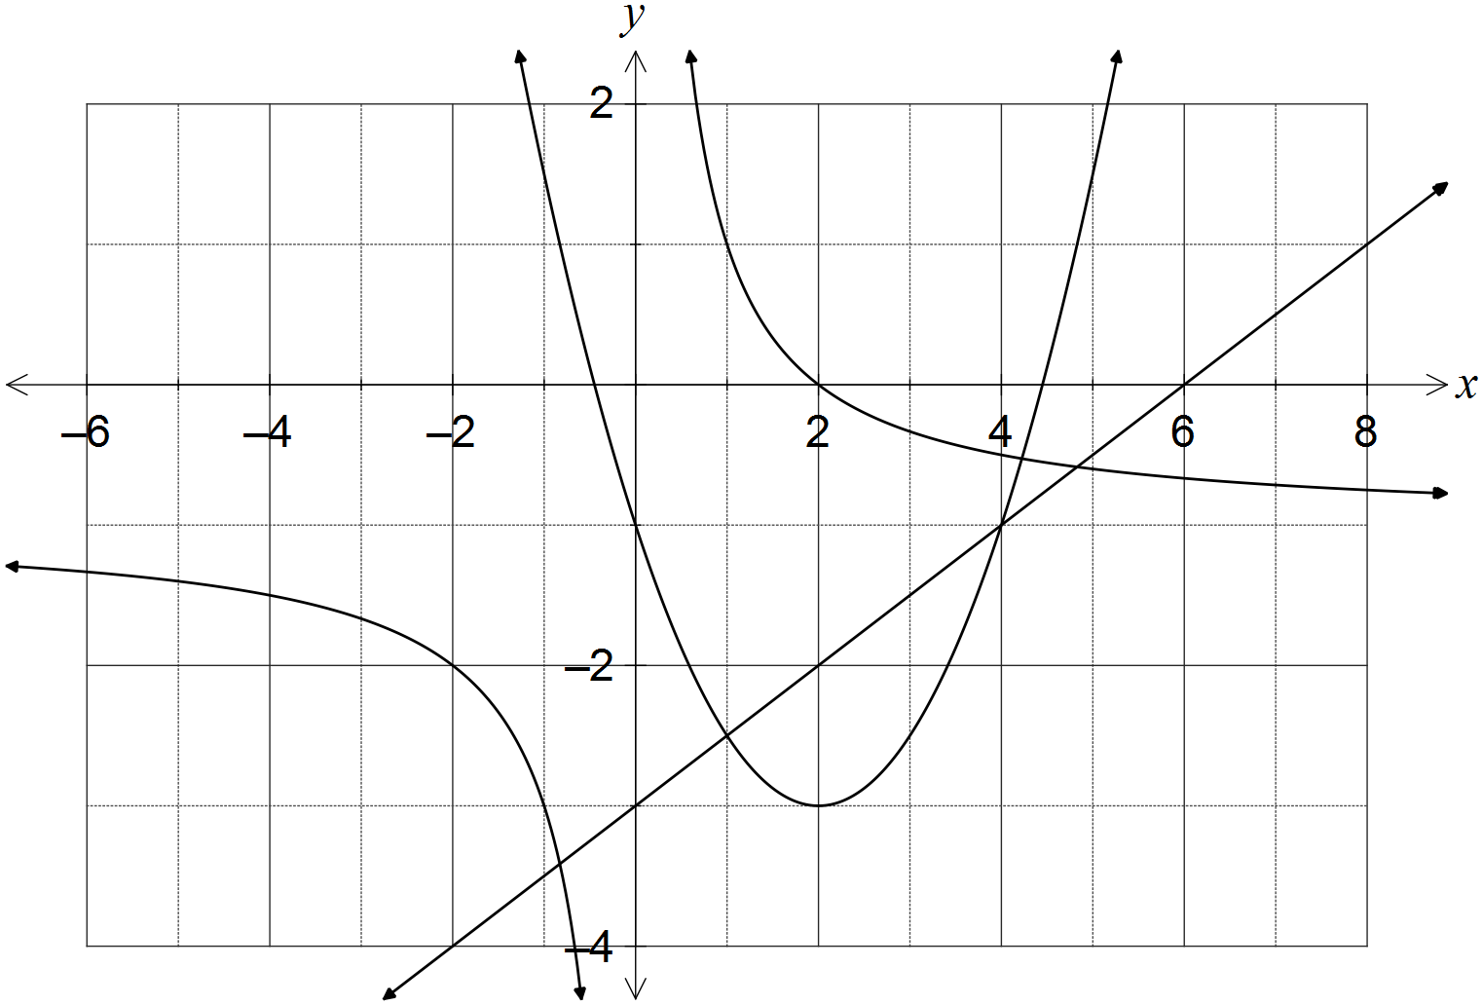

Solution
Specific behaviours
each correct value

Question 17 (9 marks)
(a) The diagram below shows the five graphs , , , and , where a, b, c and d are constants.

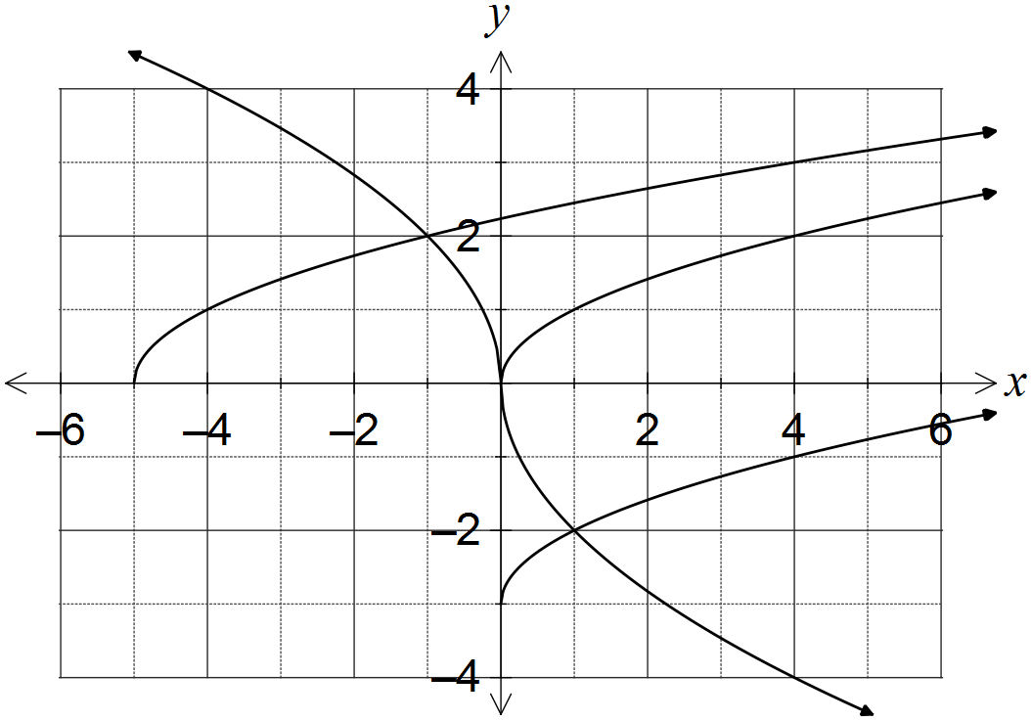

(i) Determine . (1 mark)
Solution
Specific behaviours
determines correct value

(ii) Determine the values of the constants a, b, c and d. (4 marks)
Solution
a is vertical translation:
b is horizontal translation:
c is vertical dilation and reflection in x-axis:
d is horizontal dilation and reflection in y-axis:
Specific behaviours
determines a
determines b
determines c
determines d

(b) Describe two transformations that will transform the graph of to:

(i) . (2 marks)
Solution
Translate original graph 1 unit right and 2 units downwards (in either order)
Specific behaviours
horizontal translation
vertical translation

(ii) . (2 marks)
Solution
Reflect in x-axis and dilate vertically by scale factor 5 (in either order)
Specific behaviours
reflection
dilation

Question 18 (7 marks)
In triangle ABC, , cm and cm.

Determine the largest possible area and smallest possible perimeter of this triangle.
Solution
Specific behaviours
uses sine rule to find acute angle for B
determines obtuse angle for B
calculates values of angle A
chooses largest value of A for maximum area
calculates area
chooses smallest value of A for minimum perimeter
calculates AB and states perimeter

Question 19 (8 marks)
(a) Given that , where , show how to determine the exact value of

(i) . (2 marks)
Solution
Specific behaviours
uses right triangle to determine hypotenuse
states exact value

(ii) . (2 marks)
Solution
Specific behaviours
considers sign of cos in 2nd quadrant
states exact value

(iii) . (2 marks)
Solution
Specific behaviours
substitutes into double angle identity
simplifies correctly

(b) Determine the two smallest solutions to the equation for .
(2 marks)
Solution
Using CAS: , or:
Specific behaviours
determines one solution
determines both solutions

Question 20 (7 marks)
(a) Determine the exact area of a sector enclosed by an arc of length 42 cm in a circle of radius 12 cm. (2 marks)
Solution
Specific behaviours
calculates angle
calculates exact area

(b) In the diagram below, BC is a tangent to the circle with diameter AB and centre O.
Given that cm and cm, determine the shaded area. (5 marks)

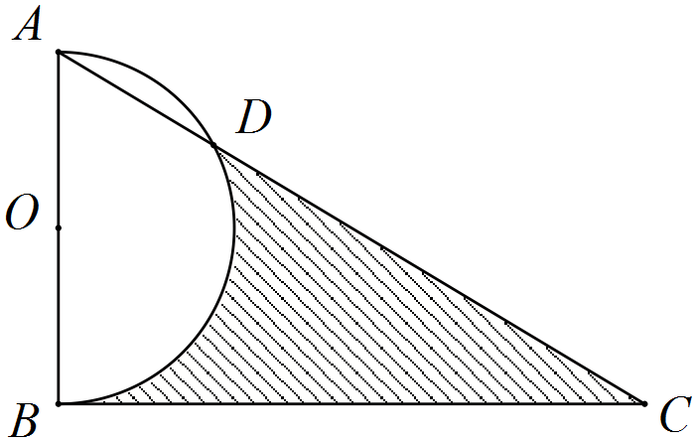

Solution
Specific behaviours
determines angle BAD
determines angle AOD
determines segment area
determines semicircle and triangle area
determines shaded area

Additional working space

Question number: _________

Additional working space

Question number: _________

Additional working space

Question number: _________

Additional working space

Question number: _________

© 2016 WA Exam Papers. Kennedy Baptist College has a non-exclusive licence to copy and communicate this paper for non-commercial, educational use within the school. No other copying, communication or use is permitted without the express written permission of WA Exam Papers.

